**CIT4014: Chapter 03 Exercises – Response**

**Name____Savier Osman____**

**Exercise 3-1:**

**Image 1 – Ex. 3-1 step 4 – In database tab showing my_guitar_shop1 and my_guitar_shop2 schemas.**

**Image 2 – Ex. 3-1 step 6 – tables of my_guitar_shop1.**

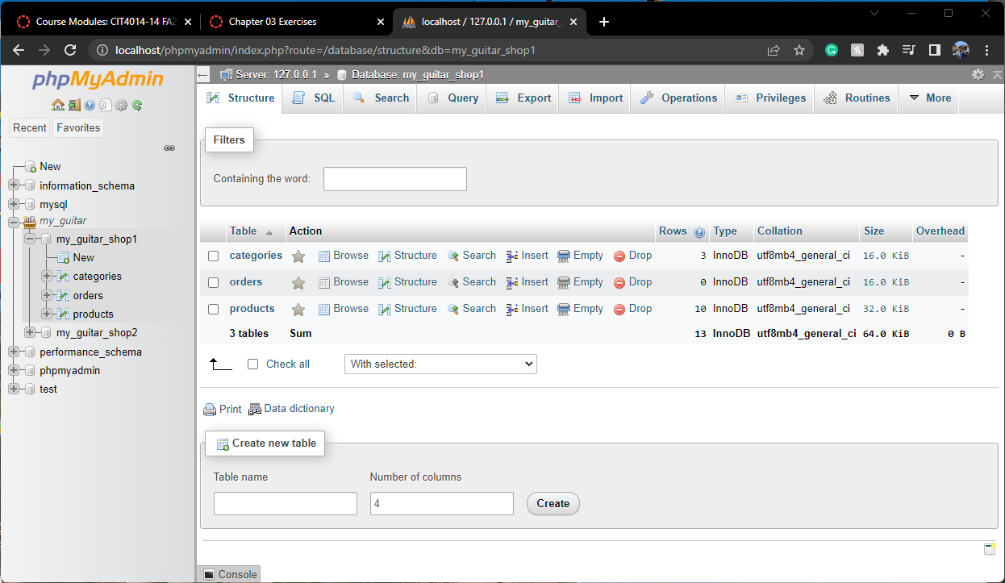

**Image 3 – Ex. 3-1 step 7 – structure of products table.**

**Image 4 – Ex. 3-1 step 8 – query result of first query in figure 3-4.**

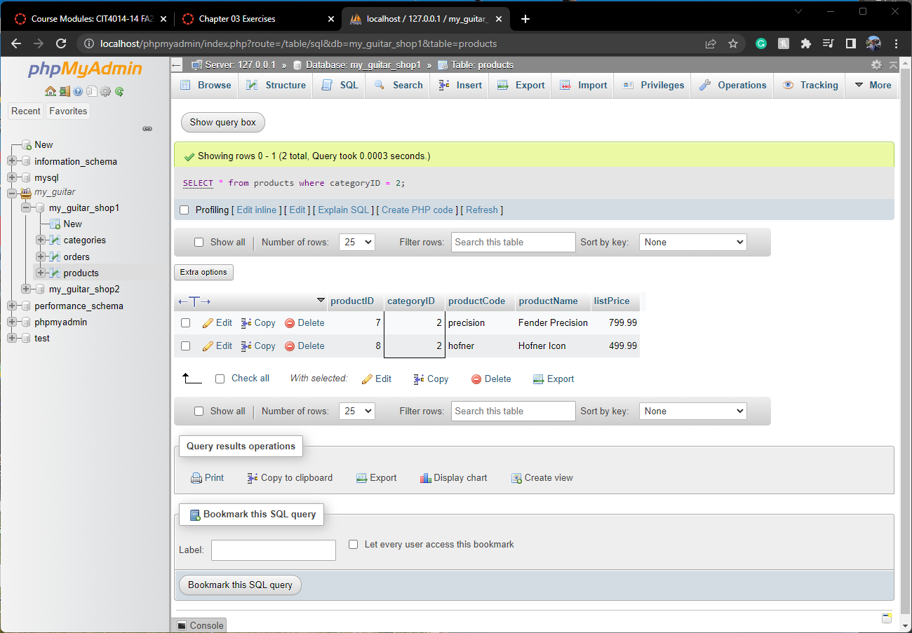

**Image 5 – Ex. 3-1 step 9 – query result of modified query in figure 3-5.**

**Image 6 – Ex. 3-1 step 10 – browser results of product table after adding new row form query in figure 3-6.**

**Image 7 – Ex. 3-1 step 10 – result of delete query to delete the record that was just added.**

